Explanation for Home Test

**Merchant's Guide to the Galaxy chooesed.**

## How to run.

The main exist in IntergalacticConversionMain.

If a file full path is passed in as the first parameter of main, the file will be used. Otherwise, the SampleInput.txt in resources folder will be used.

About input assumptions, detailed in the in the class comments of IntergalacticConversionMain

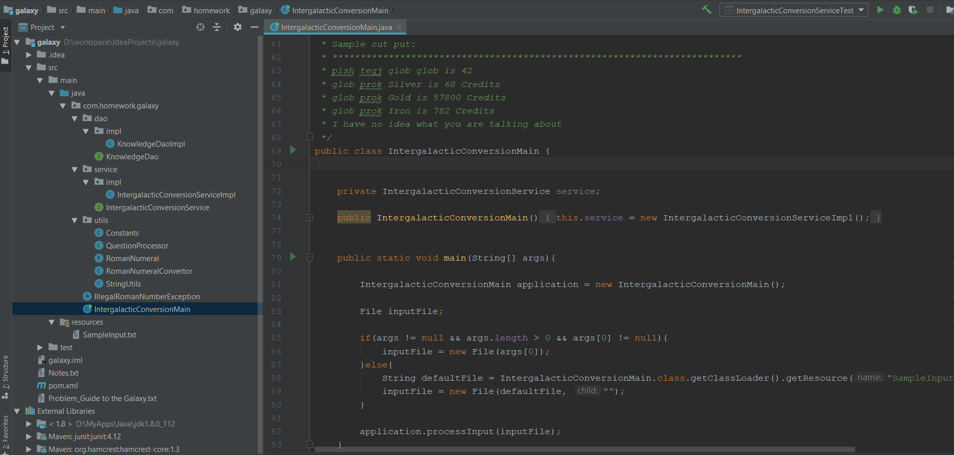

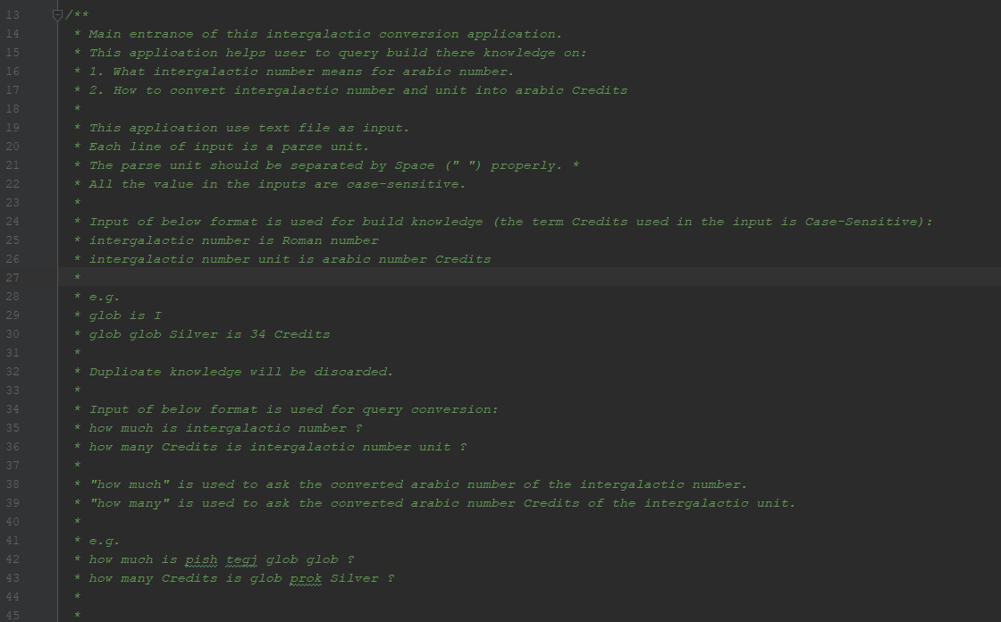

Below is result of default SampleInput.txt

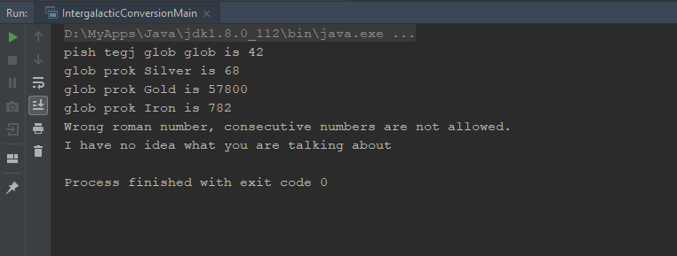

## Main structure:

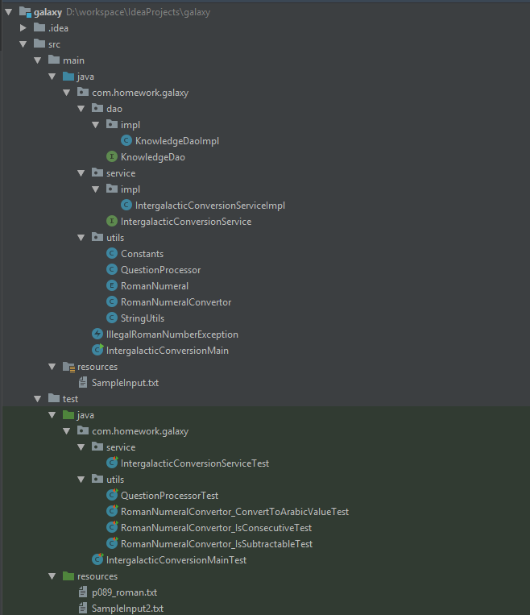

### 2.1 IntergalacticConversionMain.java

Entrance of application. And it is a dispatcher of input line, make the service do the right task (build the knowledge or answer the question).

IntergalacticConversionService.java

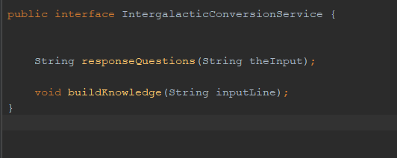

### 2.2 IntergalacticConversionService

IntergalacticConversionService is used to response the task dispatched by IntergalacticConversionMain. Its implementation IntergalacticConversionServiceImpl .java do the concreate work.

IntergalacticConversionServiceImpl.java relays on QuestionProcessor.java and KnowledgeDao.java.

### 2.3 KnowledgeDao

KnowledgeDao is abstraction of data access. And it let other components to query and write information from/to the application.

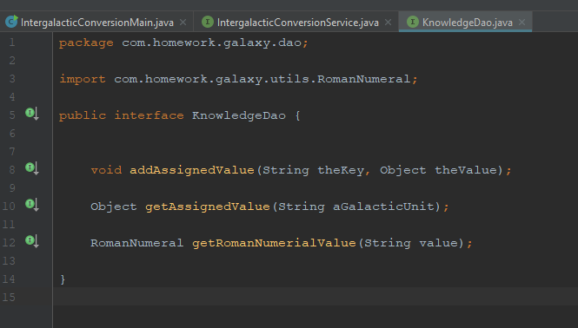

KnowledgeDaoImpl.java is the implementation of KnowledgeDao. It is a singleton object and use tow ConcurrentHashMap to handle the information.

romanNumerialsMap used to map roman symbol name and its object.

e.g: “I” -> I(1).

assignedValueMap used to map

1. Intergalactic and its equivalent roman symbo. E.g. “glob” -> “I”
2. Intergalactic unit and its equivalent Arabic number. E.g “Silver” -> 17.

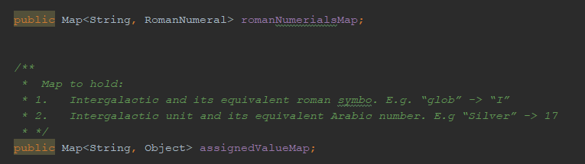

### QuestionProcessor

QuestionProcessor used to response question for IntergalacticConversionService.

### 2.5 RomanNumeralConvertor

RomanNumeralConvertor is the core convertor for application. I checks whether a roman symbols is a valid roman number. If not , IllegalRomanNumberException will be raised.

### 2.6 Others

Constants.java to hold constants

StringUtils.java to check blank string.

RomanNumeral.java enum for roman number.

### 2.7 Unit test cases

Junit test cases for main components.

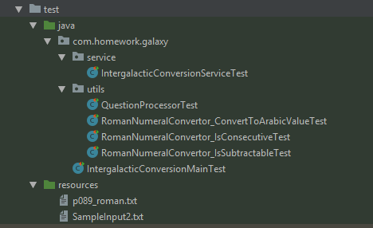

## Notes txt

There is also a Notes.txt file may help you to understand the application.

